**A Translator using AWS Translate and Boto3**

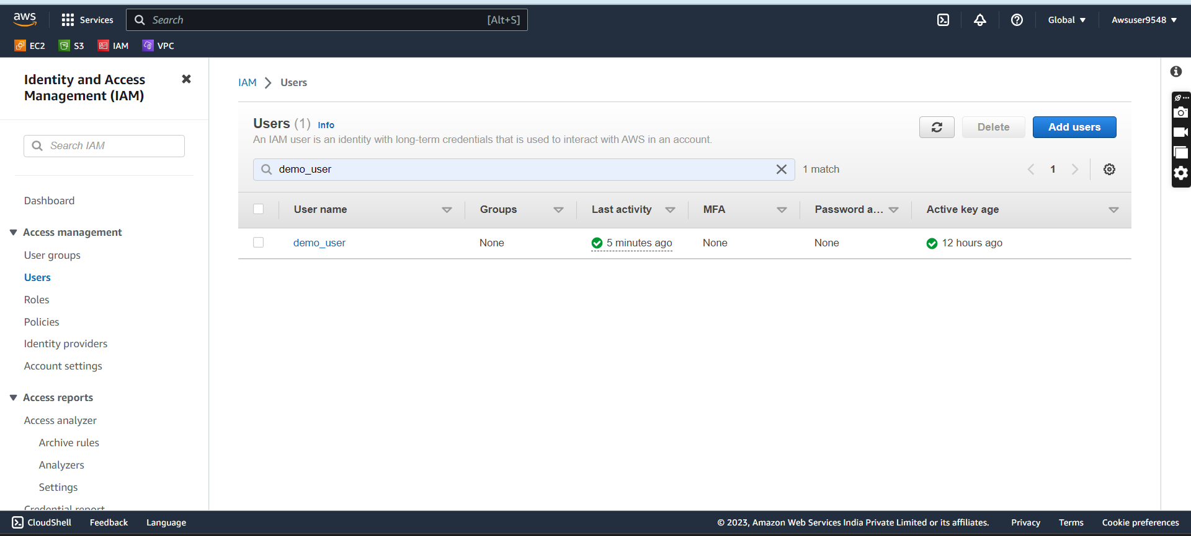

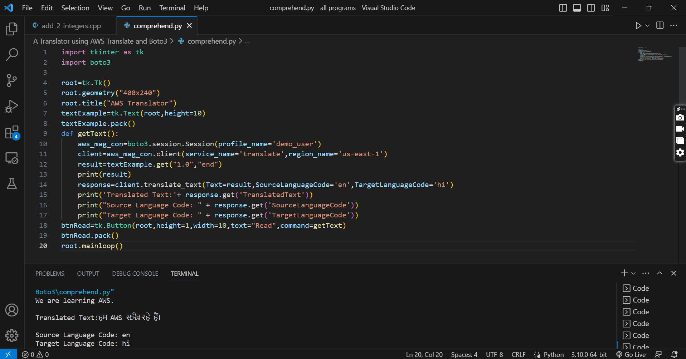

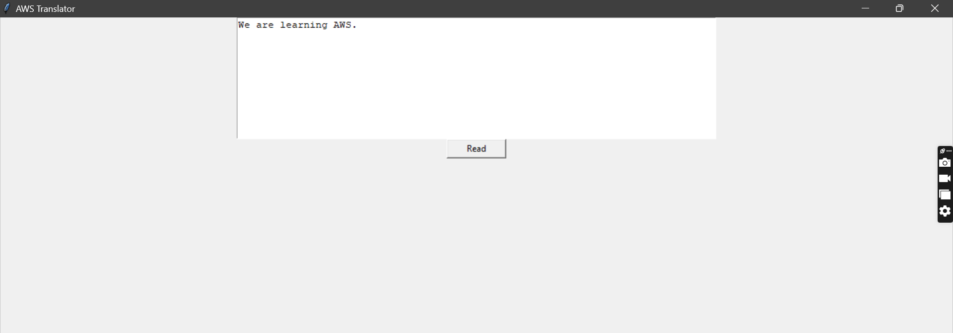

import tkinter as tk

import boto3

root=tk.Tk()

root.geometry("400x240")

root.title("AWS Translator")

textExample=tk.Text(root,height=10)

textExample.pack()

def getText():

    aws_mag_con=boto3.session.Session(profile_name='demo_user')

    client=aws_mag_con.client(service_name='translate',region_name='us-east-1')

    result=textExample.get("1.0","end")

    print(result)

    response=client.translate_text(Text=result,SourceLanguageCode='en',TargetLanguageCode='hi')

    print('Translated Text:'+ response.get('TranslatedText'))

    print("Source Language Code: " + response.get('SourceLanguageCode'))

    print("Target Language Code: " + response.get('TargetLanguageCode'))

btnRead=tk.Button(root,height=1,width=10,text="Read",command=getText)

btnRead.pack()

root.mainloop()